

Summary
This project presents an AI based network security pipeline designed to detect Denial-of-Service (DoS) attacks and support Security Operations Center (SOC) analysts. The system was developed using the CICIDS2017 dataset and compares two machine learning approaches: Random Forest for supervised classification and Isolation Forest for anomaly detection.
The dataset was preprocesses into a binary classification problem of Normal versus DoS traffic, and twelve network flow features were selected for model training. The Random Forest model achieved significantly stronger performance, reaching 98.96% accuracy and 99.45% recall, compared with 80.66% accuracy and 64.50% recall for Isolation Forest.
Based on these results, Random Forest was selected as the primary detection model. The final SOC pipeline extends beyond binary classification by incorporating confidence-based risk scoring, explainability, MITRE ATT&CK mapping, human in the loop review, audit logging, and a monitoring and retraining policy. The system does not automatically block network traffic; high-risk events are escalated to a human analyst for review.

Problem Definition
Background
Denial of Service attacks attempt to disrupt the availability of network services by overwhelming systems or network resources with excessive or malicious traffic. In a SOC environment, detecting these attacks quickly is important, but detection systems must also minimize false alarms in order to avoid unnecessary workload for analysts.
Traditional rule based detection may be effective for known attack patterns, but machine learning methods can analyse multiple characteristics of network flows simultaneously and identify patterns that may be difficult to represent using simple rules.

Problem Statement
The goal of this project is to develop an AI assisted SOC pipeline capable of distinguishing between benign network traffic and DoS activity. The system should not only classify traffic but also provide sufficient information for a SOC analyst to understand and review the detection.

Why SOC Decision Support?
A binary machine learning prediction alone is not sufficient for a practical SOC workflow. Analysts also require information about the confidence of the detection, the severity of the event, supporting evidence, attack classification, and traceability of decisions. Therefore, the project combines machine learning detection with risk scoring, explainability, MITRE ATT&CK mapping, human review, and audit logging.

Project Objectives
The main objective of the project is to design and evaluate an AI based pipeline for DoS detection in a SOC environment.
- Detect Normal and DoS network traffic using machine learning.
- Compare supervised classification with anomaly detection.
- Evaluate the models using security relevant metrics.
- Generate a confidence based SOC risk level.
- Provide explainable evidence for alerts.
- Map detected DoS activity to MITRE ATT&CK.
- Keep a human analyst in the decision loop.
- Maintain an audit log of analyzed events.
- Define a monitoring and retraining policy.

System Architecture
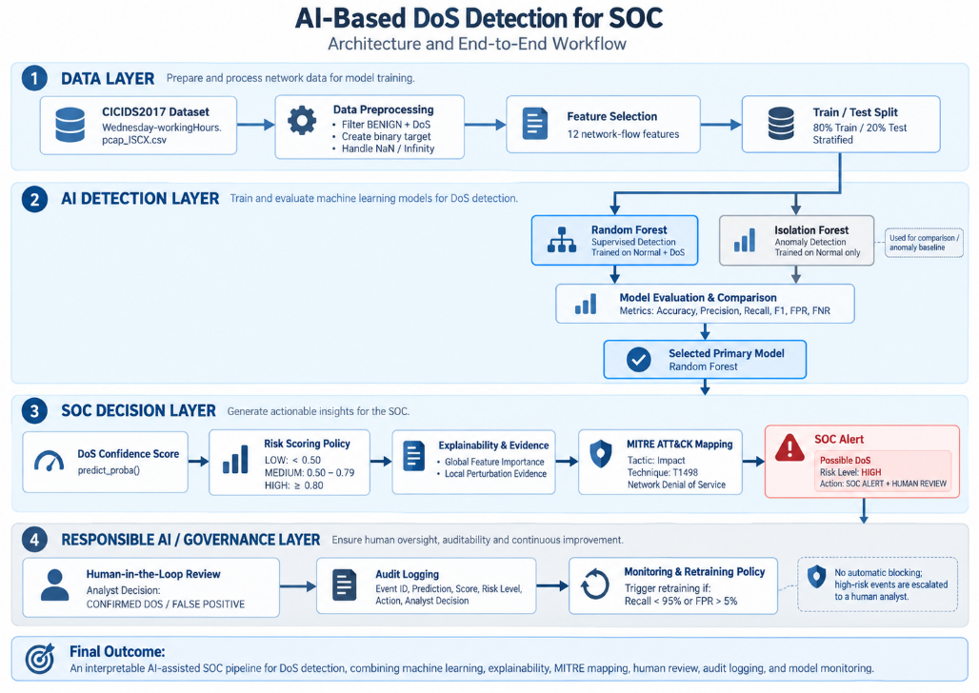
Figure 1 – End to End Architecture of the AI Based DoS Detection System

Figure 1 presents the complete system architecture. The pipeline begins with the CICIDS2017 dataset and includes preprocessing, feature selection, and an 80/20 train test split. Two machine learning approaches are evaluated: Random Forest and Isolation Forest. Based on the evaluation results, Random Forest is selected as the primary detection model.
Its output is converted into a DoS confidence score and processed by a policy gate that assigns LOW, MEDIUM, or HIGH risk. Supporting evidence and MITRE ATT&CK information are then presented to the SOC analyst. Medium and high risk events require human review, and all events are stored in an audit log. Finally, a monitoring policy determines whether the model may require retraining.

Dataset and Data Preparation
Dataset
The CICIDS2017 dataset was selected because it contains labeled network traffic representing both benign activity and multiple cyberattack categories. For this project, the Wednesday working hours dataset was used because it contains several types of DoS attacks together with benign network traffic.

Label | Number of Samples
 | 440,031
  BENIGN
DoS Hulk | 231,073
DoS GoldenEye | 10,293
DoS slowloris | 5,796
DoS Slowhttptest | 5,499
Heartbleed | 11

The original Wednesday working-hours file contains 692,703 network-flow samples. Since this project focuses specifically on DoS detection, the Heartbleed samples were excluded during preprocessing, while BENIGN traffic and the four DoS attack categories were retained for further analysis.

Preprocessing
The original dataset contains several attack categories. Since the project focuses specifically on DoS detection, only benign traffic and labels beginning with “DoS” were retained.
The original textual labels were converted into a binary target variable:
0 = Normal
1 = DoS
Missing and infinite values were also handled before training in order to ensure compatibility with the machine-learning models.

The resulting dataset contained approximately 691,395 network flows, including 439,683 Normal samples and 251,712 DoS samples.

Feature Selection
Twelve network flow features were selected as the input variables for the models. These features represent flow duration, traffic volume, packet rates, packet lengths, and TCP flag behavior.

Feature | Description
Flow Duration | Duration of the network flow
Total Fwd Packets | Number of forward packets
Total Backward Packets
  Number of backward packets
Total Length of Fwd Packets | Total forward traffic size
Total Length of Bwd Packets | Total backward traffic size
Flow Bytes/s | Bytes transferred per second
Flow Packets/s | Packets transferred per second
Fwd Packet Length Mean | Average forward packet size
Bwd Packet Length Mean | Average backward packet size
Packet Length Mean | Average packet size
SYN Flag Count | Number of SYN flags
ACK Flag Count | Number of ACK flags

These twelve features were used as the input variables $X$, while the binary Normal/DoS target was used as $y$.

Experimental Methodology
Train/Test Split
The dataset was divided using an 80/20 stratified train-test split. Stratification preserved the Normal/DoS class proportions in both subsets. The training set contained 553,116 samples, while the test set contained 138,279 samples.
The same test set was used for the final comparison of the two approaches.

Machine Learning Models
Random Forest
Random Forest was selected as the supervised-learning approach. The model was trained using labelled Normal and DoS traffic. One hundred decision trees were used, and the final classification was obtained by combining their predictions.
Because the model receives labelled examples of both classes during training, it can learn patterns that distinguish known DoS traffic from benign traffic.

Isolation Forest
Isolation Forest was used as the anomaly-detection approach. Unlike Random Forest, it was trained only on Normal traffic and did not receive DoS labels during training.
The objective of Isolation Forest is therefore not to directly recognize a DoS attack, but rather to determine whether a new network flow appears abnormal relative to learned Normal behaviour.
This provides an important comparison between supervised detection of known attacks and anomaly based detection.

Evaluation Metrics
Model performance was evaluated using multiple metrics rather than Accuracy alone.
- Accuracy – The percentage of all predictions that were classified correctly.
- Precision – Out of all samples predicted as DoS, the percentage that were actually DoS attacks.
- Recall – Out of all actual DoS attacks, the percentage that were successfully detected by the model.
- F1 Score – A balanced measure that combines Precision and Recall.
- False Positive Rate (FPR) – The percentage of Normal traffic that was incorrectly classified as DoS.
- False Negative Rate (FNR) – The percentage of actual DoS attacks that were incorrectly classified as Normal traffic.
Recall and False Negative Rate are particularly important in a cybersecurity context because missed attacks may represent a significant security risk.

Results
Model Comparison
Metric | Random Forest | Isolation Forest
Accuracy | 98.96% | 80.66%
Precision | 97.73% | 78.55%
Recall | 99.45% | 64.50%
F1 Score | 98.58% | 70.83%
FPR | 1.32% | 10.08%
FNR | 0.55% | 35.50%

Random Forest substantially outperformed Isolation Forest across all evaluated metrics. In particular, the difference in Recall is important: Random Forest detected 99.45% of the DoS samples, while Isolation Forest detected approximately 64.50%.
Isolation Forest also produced a significantly higher False Negative Rate, indicating that a large number of known DoS attacks were not identified as anomalous.
Figure 2 – Performance Comparison between Random Forest and Isolation Forest
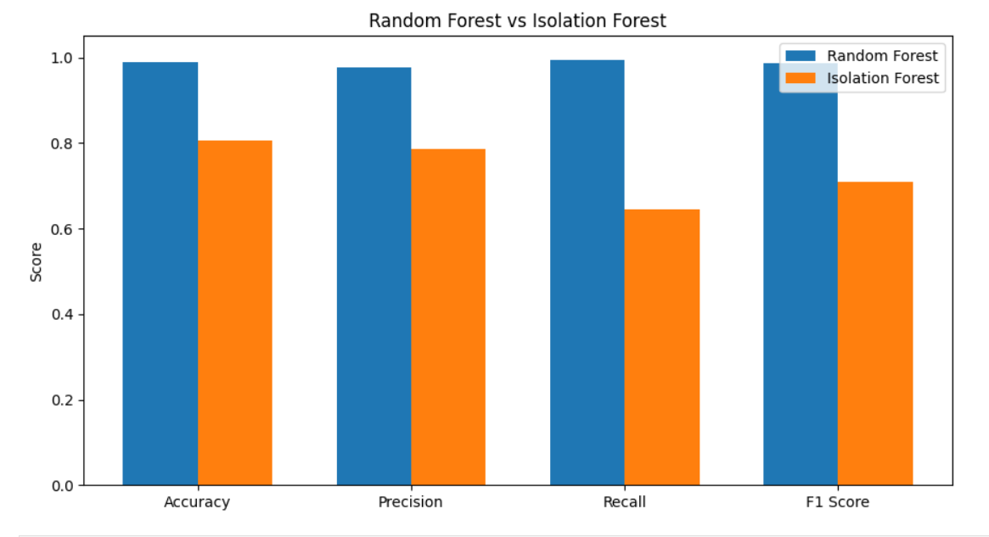
As shown in Figure 3, Random Forest achieved consistently higher performance than Isolation Forest across all four main classification metrics. The largest difference appears in Recall, where Random Forest achieved 99.45%, while Isolation Forest achieved 64.50%. This indicates that Random Forest was considerably more effective at detecting the known DoS samples in the test set.
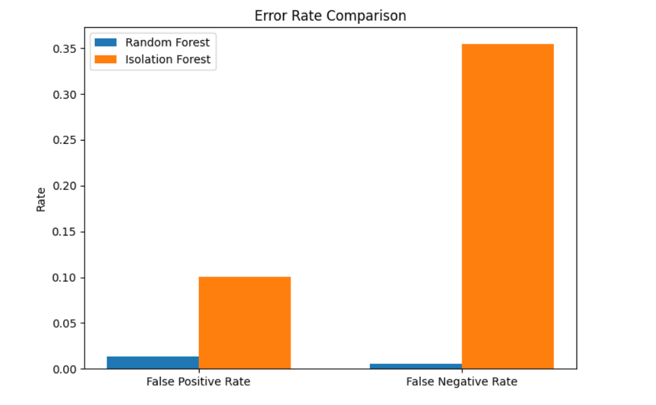
Figure 3 – False Positive and False Negative Rate Comparison

Figure 4 shows the error-rate comparison between the two evaluated models. Random Forest achieved a much lower False Positive Rate (1.32%) and False Negative Rate (0.55%) than Isolation Forest, which reached 10.08% and 35.50%, respectively. This difference is especially important in a cybersecurity context, since a high False Negative Rate means that many real attacks are missed by the system.

Random Forest Confusion Matrix
The Random Forest confusion matrix shows that 50,067 DoS samples were correctly detected, while only 275 DoS samples were incorrectly classified as Normal. In addition, 86,773 Normal samples were correctly classified and 1,164 were incorrectly flagged as DoS.

Figure 4– Random Forest Confusion Matrix
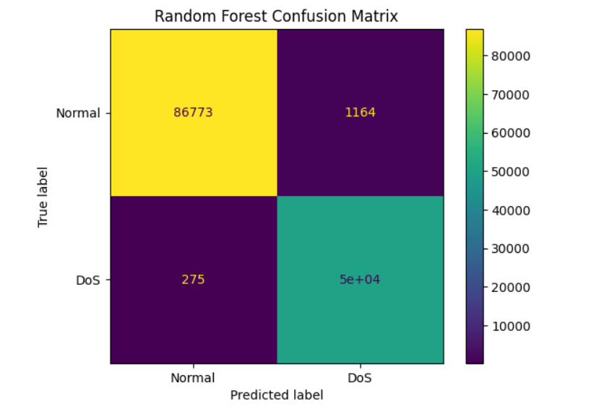

Model Selection
Based on the experimental results, Random Forest was selected as the primary model for the SOC detection pipeline.
The decision was based mainly on its very high Recall, low False Negative Rate, and considerably lower False Positive Rate compared with Isolation Forest.
Isolation Forest remains conceptually valuable because anomaly-detection techniques may identify unusual traffic that does not match previously labeled attacks. However, for the labeled DoS detection task evaluated in this project, Random Forest provided substantially stronger performance.

SOC Risk Scoring and Policy Gate
Instead of presenting only a binary prediction, the Random Forest model's class score was used as a DoS confidence score.
Policy:
Score | Risk Level | SOC Action
< 0.50 | LOW | Log only
0.50–0.79 | MEDIUM | Human review
≥ 0.80 | HIGH | SOC alert + human review

The thresholds represent a prototype SOC policy and were not claimed to be mathematically optimal. Their purpose is to demonstrate how model output can be transformed into operational SOC decisions.
The system does not automatically block network traffic. High-risk events are escalated to a human analyst.

Explainability and Evidence
Global Feature Importance
Random Forest feature importance was used to analyze which variables contributed most strongly to the model across the full dataset.

Figure 5 – Random Forest Global Feature Importance
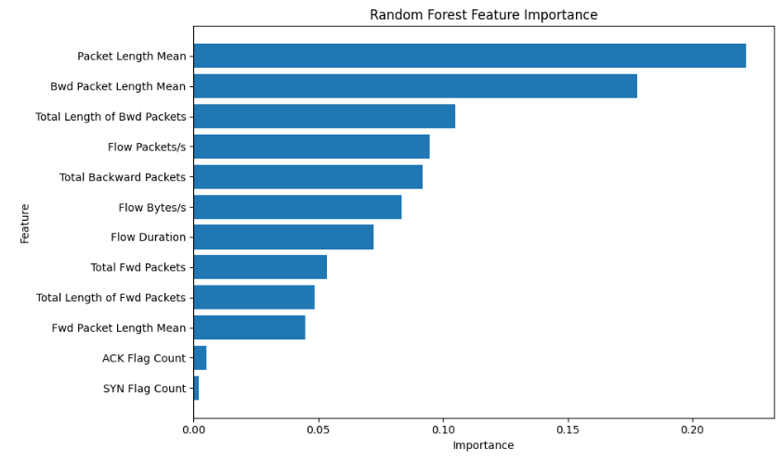

Local Evidence
Global feature importance does not explain why a specific event was classified as suspicious. Therefore, a local perturbation approach was also implemented.
For a selected alert, each feature was individually replaced by the median value observed in Normal training traffic. The model score was then recalculated. The decrease in the DoS score was used as an indication of the local importance of that feature for the selected event.

Feature | Impact
ACK Flag Count | 0.9660
Fwd Packet Length Mean | 0.3797
Packet Length Mean | 0.3715

The local evidence should be interpreted as supporting information for the analyst rather than as proof of causal relationships.

MITRE ATT&CK Mapping
Detected DoS activity was mapped to the MITRE ATT&CK framework to provide a standardized description of the identified threat.
Field | Value
Tactic | Impact
Technique ID | T1498
Technique | Network Denial of Service

MITRE ATT&CK is not used to perform the detection itself. The machine-learning model performs the detection, while the MITRE mapping provides standardized security context for the SOC analyst.

Human in the Loop
To avoid fully automated security decisions, the system includes a Human in the Loop process.
Medium and high-risk events are escalated to an analyst. The analyst may classify the alert as CONFIRMED DOS or FALSE POSITIVE. Events that have not yet been reviewed remain in a PENDING REVIEW state.

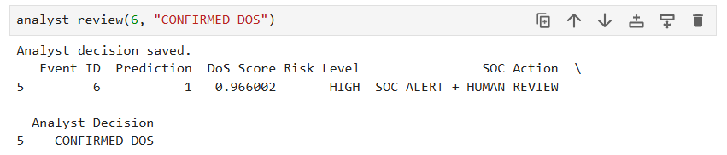
Figure 6 – Example of Analyst Review

SOC Alert Example
Figure 7 – Example SOC Alert Generated by the System
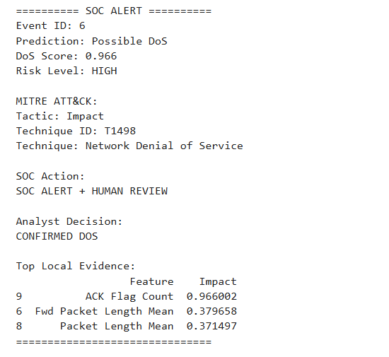

Audit Logging
All evaluated events are stored in an audit log. The log contains the Event ID, prediction, DoS score, risk level, SOC action, analyst decision, and the experimental ground-truth label.
This enables traceability and supports future analysis of both model and analyst decisions.
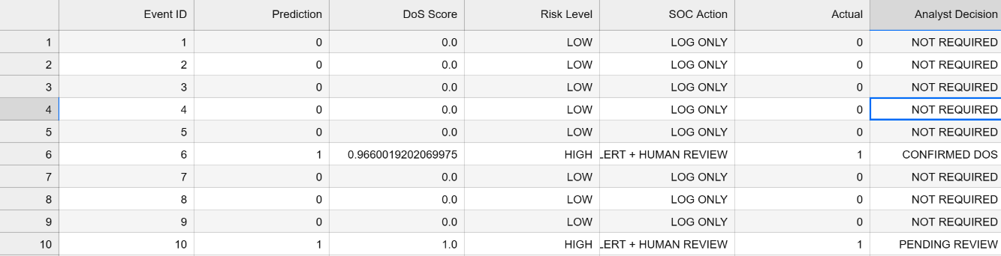
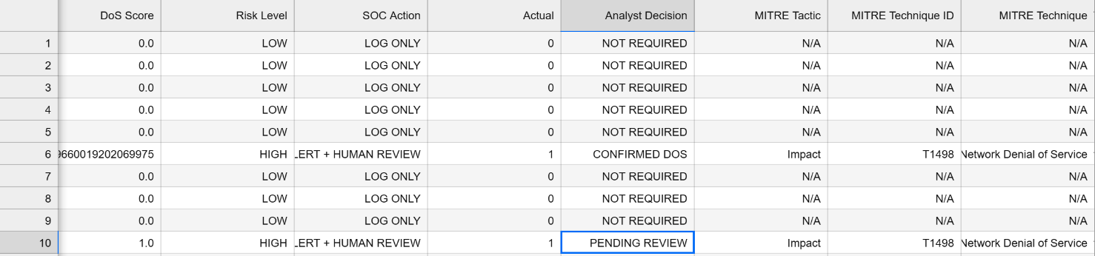
The Actual field is available only for experimental evaluation because CICIDS2017 is a labeled dataset. In a real-time operational system, ground truth would generally not be available at detection time.

Monitoring and Retraining Policy
To maintain reliable detection performance over time, a simple monitoring policy was defined for the selected Random Forest model. Two security-relevant metrics are monitored: Recall and False Positive Rate (FPR).
Retraining is recommended if:
- Recall falls below 95%, or
- False Positive Rate rises above 5%.
In the current evaluation, the Random Forest achieved a Recall of 99.45% and an FPR of 1.32%. Since both values remain within the defined thresholds, the current model status is considered MODEL PERFORMANCE STABLE, and retraining is not required.
In this prototype, the monitoring policy is demonstrated using the test-set results. In a real production environment, these metrics would be evaluated periodically on newly labeled network traffic in order to identify performance degradation or possible model drift.

Responsible AI and Security Considerations
Several design choices were included to improve the responsible use of AI in the SOC workflow:
• No automatic blocking is performed.
• High-risk events require human review.
• Model decisions are accompanied by supporting evidence.
• Analyst decisions are logged for auditability.
• Model performance is monitored using security-relevant thresholds.
• Only selected network-flow features are used rather than unnecessary personal information.

Limitations
The project has several limitations. First, evaluation was performed using a train-test split from CICIDS2017, and therefore the reported performance does not guarantee equivalent performance on traffic from different organizations or modern production networks.
Second, the project focuses specifically on DoS traffic and does not attempt to detect every cyberattack category.
Third, the defined risk thresholds are policy choices and were not optimized as part of this study.
Fourth, the local perturbation evidence provides interpretability but should not be interpreted as causal explanation.
Finally, the monitoring mechanism demonstrates a retraining policy rather than full longitudinal concept-drift detection.

Future Work
Future development could include:
• Evaluation on additional datasets and unseen network environments.
• Real-time network-stream processing.
• Additional attack categories.
• Automatic drift analysis across time windows.
• Integration with a SIEM platform.
• Cloud or GPU acceleration using technologies such as RAPIDS or NVIDIA Morpheus.
• Additional explainability methods.
• Calibration and optimization of SOC risk thresholds.

Conclusions
This project demonstrated an end-to-end AI-assisted SOC pipeline for the detection of DoS attacks using the CICIDS2017 dataset.
Two machine-learning approaches were compared. Random Forest achieved significantly stronger performance than Isolation Forest, including 99.45% Recall and a 0.55% False Negative Rate, and was therefore selected as the primary detection model.
Beyond classification, the project incorporated confidence-based risk scoring, explainable evidence, MITRE ATT&CK mapping, human analyst review, audit logging, and a model-monitoring policy. These components demonstrate how machine-learning detection can be integrated into a more interpretable, auditable, and responsible SOC workflow.
The results show that supervised learning can be highly effective for detecting known DoS patterns in the selected dataset, while further evaluation on new network environments would be required before operational deployment.

